BUKTI KORESPONDENSI
ARTIKEL JURNAL INTERNASIONAL BEREPUTASI

Judul artikel : We need to talk about kinship: How kinship weakens turnover intentions among academicians at private higher education institutions in Indonesia
Jurnal : Journal of Applied Research in Higher Education
Penulis : Eka Pariyanti, Wiwiek Rabiatul Adawiyah, Siti Zulaikha Wulandari

No | Perihal | Tanggal
1 | Bukti konfirmasi submit artikel dan artikel yang  disubmit | 14-Apr-2022
2 | Bukti konfirmasi review dan hasil review pertama | 19-Jun-2022
3 | Bukti konfirmasi submit revisi pertama, respon  kepada reviewer, dan artikel yang diresubmit | 01-Aug-2022
8 | Bukti konfirmasi artikel accepted | 19-Aug-2022
9 | Bukti konfirmasi artikel published online | 15-Sept-2022

Bukti konfirmasi submit artikel dan artikel yang diubmit 14-Apr-2022
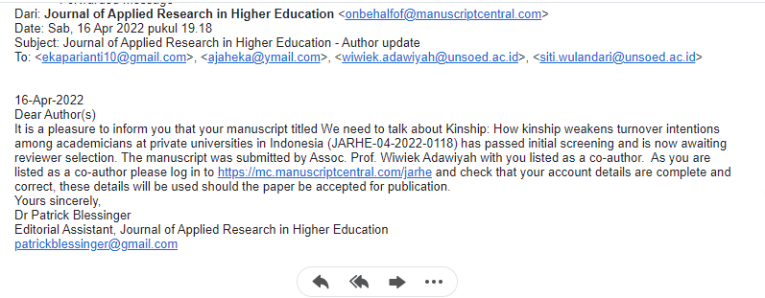

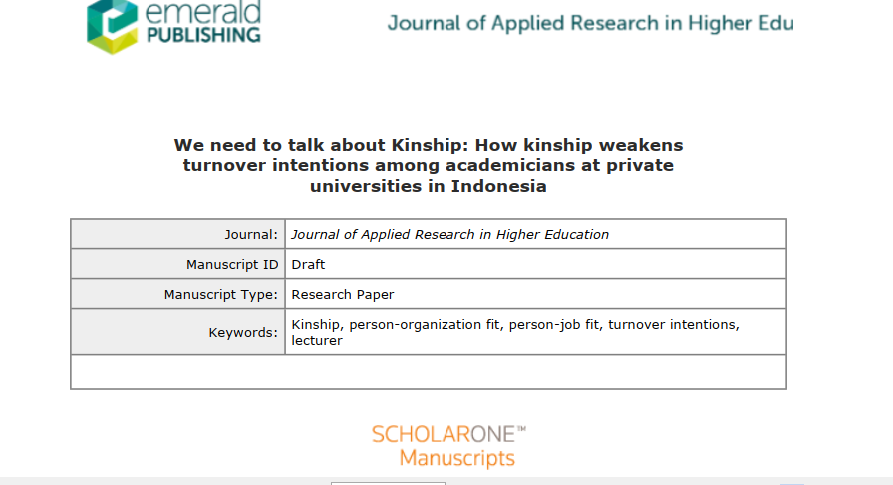

Bukti konfirmasi review dan hasil review pertama 19-Jun-2022

Journal of Applied Research in Higher Education

Decision Letter (JARHE-04-2022-0118.R1)
From: | martina@up.ac.za
To: | ekaparianti10@gmail.com, ajaheka@ymail.com, wiwiek.adawiyah@unsoed.ac.id, siti.wulandari@unsoed.ac.id
CC:
Subject: | Journal of Applied Research in Higher Education - Decision on Manuscript ID JARHE-04-2022-0118.R1
Body: | 19-Aug-2022  Dear PARIYANTI, EKA; Adawiyah, Wiwiek; Wulandari, Siti  It is a pleasure to accept your manuscript JARHE-04-2022-0118.R1, entitled "We need to talk about kinship: How kinship weakens turnover intentions among academicians at private higher education institutions in Indonesia" in its current form for publication in Journal of Applied Research in Higher Education. Please note, no further changes can be made to your manuscript.  Please go to your Author Centre at https://mc.manuscriptcentral.com/jarhe (Manuscripts with Decisions for the submitting author or Manuscripts I have co-authored for all listed co-authors) to complete the Copyright Transfer Agreement form (CTA). We cannot publish your paper without this.  All authors are requested to complete the form and to input their full contact details. If any of the contact information is incorrect you can update it by clicking on your name at the top right of the screen. Please note that this must be done prior to you submitting your CTA.  If you have an ORCID please check your account details to ensure that your ORCID is validated.  By publishing in this journal your work will benefit from Emerald EarlyCite. As soon as your CTA is completed your manuscript will pass to Emerald’s Content Management department and be processed for EarlyCite publication. EarlyCite is the author proofed, typeset version of record, fully citable by DOI. The EarlyCite article sits outside of a journal issue and is paginated in isolation. The EarlyCite article will be collated into a journal issue according to the journals’ publication schedule.  FOR OPEN ACCESS AUTHORS: Please note if you have indicated that you would like to publish your article as Open Access via Emerald’s Gold Open Access route, you are required to complete a Creative Commons Attribution Licence - CCBY 4.0 (in place of the standard copyright assignment form referenced above). You will receive a follow up email within the next 30 days with a link to the CCBY licence and information regarding payment of the Article Processing Charge. If you have indicated that you might be eligible for a prepaid APC voucher, you will also be informed at this point if a voucher is available to you (for more information on APC vouchers please see http://www.emeraldpublishing.com/oapartnerships  Thank you for your contribution. On behalf of the Editors of Journal of Applied Research in Higher Education, we look forward to your continued contributions to the Journal.  Sincerely,  Dr. Martina Jordaan  Senior Editor, Journal of Applied Research in Higher Education  martina@up.ac.za  Tell us how we're doing! We’d love to hear your feedback on the submission and review process to help us to continue to support your needs on the publishing journey.  Simply click this link https://eu.surveymonkey.com/r/F8GZ2XW to complete a short survey and as a thank you for taking part you have the option to be entered into a prize draw to win £100 in Amazon vouchers. To enter the prize draw you will need to provide your email address.
Date Sent: | 19-Aug-2022

© Clarivate | © ScholarOne, Inc., 2022. All Rights Reserved.

Bukti konfirmasi submit revisi pertama, respon kepada reviewer, dan artikel yang diresubmit 01-Aug-2022
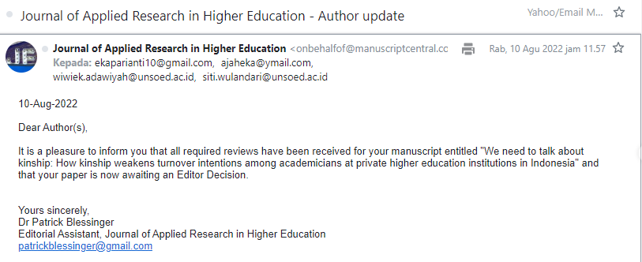

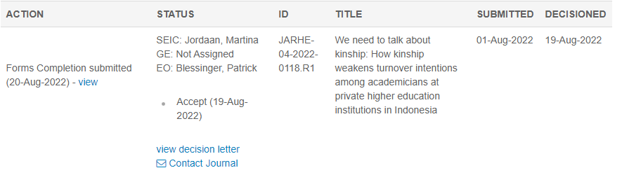

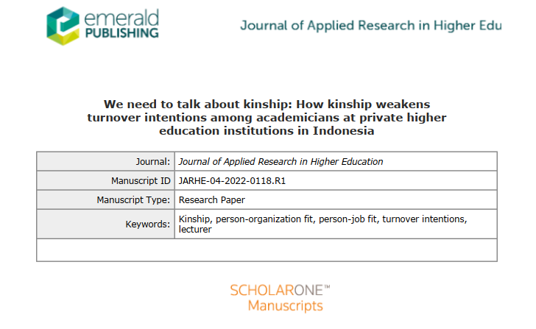

Note : R1 pada ID = REVISI KE 1

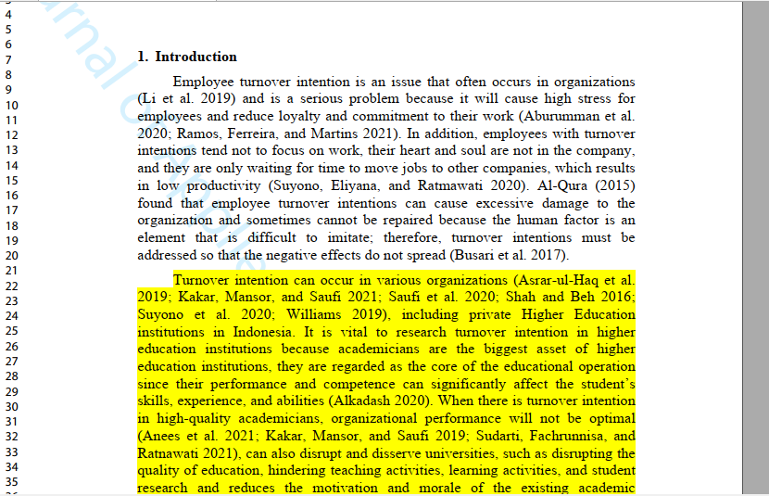

Bukti konfirmasi artikel accepted 19-Aug-2022

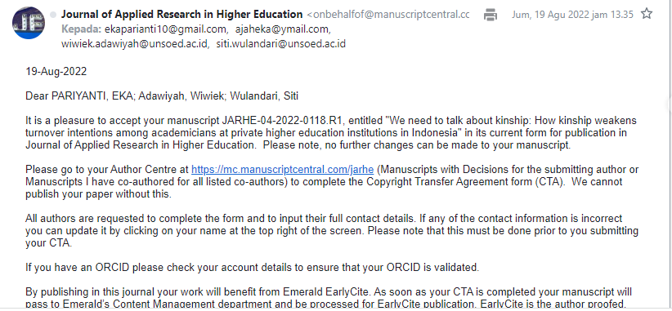

Journal of Applied Research in Higher Education

Decision Letter (JARHE-04-2022-0118.R1)
From: | martina@up.ac.za
To: | ekaparianti10@gmail.com, ajaheka@ymail.com, wiwiek.adawiyah@unsoed.ac.id, siti.wulandari@unsoed.ac.id
CC:
Subject: | Journal of Applied Research in Higher Education - Decision on Manuscript ID JARHE-04-2022-0118.R1
Body: | 19-Aug-2022  Dear PARIYANTI, EKA; Adawiyah, Wiwiek; Wulandari, Siti  It is a pleasure to accept your manuscript JARHE-04-2022-0118.R1, entitled "We need to talk about kinship: How kinship weakens turnover intentions among academicians at private higher education institutions in Indonesia" in its current form for publication in Journal of Applied Research in Higher Education. Please note, no further changes can be made to your manuscript.  Please go to your Author Centre at https://mc.manuscriptcentral.com/jarhe (Manuscripts with Decisions for the submitting author or Manuscripts I have co-authored for all listed co-authors) to complete the Copyright Transfer Agreement form (CTA). We cannot publish your paper without this.  All authors are requested to complete the form and to input their full contact details. If any of the contact information is incorrect you can update it by clicking on your name at the top right of the screen. Please note that this must be done prior to you submitting your CTA.  If you have an ORCID please check your account details to ensure that your ORCID is validated.  By publishing in this journal your work will benefit from Emerald EarlyCite. As soon as your CTA is completed your manuscript will pass to Emerald’s Content Management department and be processed for EarlyCite publication. EarlyCite is the author proofed, typeset version of record, fully citable by DOI. The EarlyCite article sits outside of a journal issue and is paginated in isolation. The EarlyCite article will be collated into a journal issue according to the journals’ publication schedule.  FOR OPEN ACCESS AUTHORS: Please note if you have indicated that you would like to publish your article as Open Access via Emerald’s Gold Open Access route, you are required to complete a Creative Commons Attribution Licence - CCBY 4.0 (in place of the standard copyright assignment form referenced above). You will receive a follow up email within the next 30 days with a link to the CCBY licence and information regarding payment of the Article Processing Charge. If you have indicated that you might be eligible for a prepaid APC voucher, you will also be informed at this point if a voucher is available to you (for more information on APC vouchers please see http://www.emeraldpublishing.com/oapartnerships  Thank you for your contribution. On behalf of the Editors of Journal of Applied Research in Higher Education, we look forward to your continued contributions to the Journal.  Sincerely,  Dr. Martina Jordaan  Senior Editor, Journal of Applied Research in Higher Education  martina@up.ac.za  Tell us how we're doing! We’d love to hear your feedback on the submission and review process to help us to continue to support your needs on the publishing journey.  Simply click this link https://eu.surveymonkey.com/r/F8GZ2XW to complete a short survey and as a thank you for taking part you have the option to be entered into a prize draw to win £100 in Amazon vouchers. To enter the prize draw you will need to provide your email address.
Date Sent: | 19-Aug-2022

